Chunking Activity (Links in the Same Page)

PRINT THIS PAGE AND REFER TO IT AS YOU WORK
Chunking is a term that refers to linking from one location to another location, usually on the same page. (See p63, Carey 6)

- For this activity, start with this document, Chunking activity, and use 3 other files that are in the chunking folder:
  - chunking_orig.htm - original file that you will modify
  - chunking_answer.htm - answer placing id inside of h2
  - chunking_ answer with div - answer placing id inside of div

- Study the Chunking Example to Study on the next page.

Complete exercise (steps 3 – 4) :
- Open the page called chunking_orig.htm in a browser and observe the page, Notice the Table of Contents towards the top of its page:
Rationale for LOGIC
Overview
Definitions

Your task is to link each of the 3 Table of Content items to each of its 3 corresponding sections in the page. Start with the file chunking_orig.htm. Use an editor such as Notepad or Komodo Edit. After coding the page, be sure to test each link. I suggest that you restore your browser to a smaller size (height) such that you can clearly observe the linkage in the rendered page. After completing the coding, you page should look like the picture below:
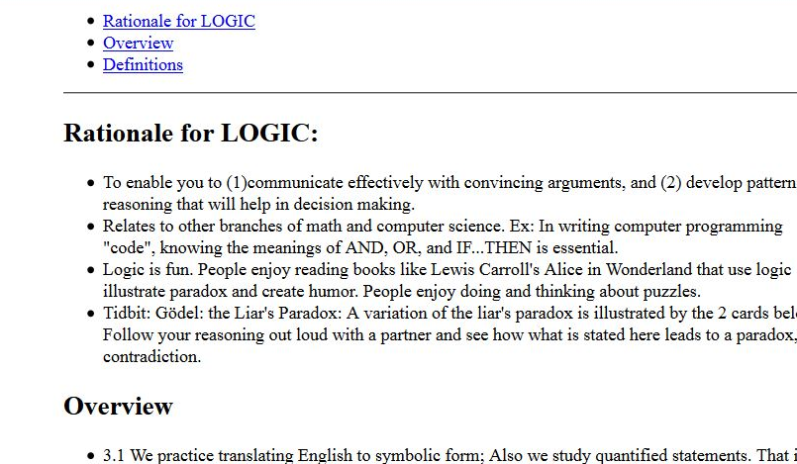
Check your code with chunking_answer.htm page.

- Go back and re-code just the third line, <h2>Definitions</h2> using the <div> element. Instead of placing the id attribute inside of the opening <h2>, do the following. Surround the entire original line (<h2>Definitions</h2>) with the <div> and </div>. Then insert the id attribute inside of the opening <div> tag. Check your code with chunking_answer_w_div.htm page.
Chunking Example to Study

The hyperlink links you FROM ONE LOCATION ON THE PAGE TO ANOTHER LOCATION ON THE PAGE. At the FROM location the <a> element with href attribute is used and at the TO location the id attribute is used. The <a> element links from where it is on the page to a different place on the page where you labeled an id.

Suppose you have a very long (3 printed pages long, say) web page as pictured below, left. As a convenience to the reader of this long web page, you can link the phrase “Chapter 2” up in the top, in the Table of Contents to the section called “Chapter 2 Middle” in the document, further below. So, if one clicks on Chapter 2 at the top he is linked to the section “Chapter 2 Middle” further down the page.
Step 2: Use the <a> element at the FROM location, and set href equal to the id you added at the place you are linking TO. Precede it with a # sign.

Re-code the line Chapter 2
as
<a href=”#chap2”>Chapter 2</a>

Step 1: Identify where you are linking TO by labeling it with the id attribute:

Insert the id attribute inside its opening tag: Suppose that Chapter 2 Middle is inside of h3 tags.
Ex: <h3>Chapter 2 Middle</h3>.

Re-code this line as
<h3 id=“chap2”>Chapter 2 Middle</h3>

Or, use <div> and id attribute:
<div id=“chap2”><h3>Chapter 2 Middle</h3></div>

Recall generic tags span and div:
The <span> tag marks a word or line (text-level element).
The <div> tag marks a larger block such as 1 or more paragraphs (grouping element). Then this block can be identified with the id attribute.

The value for id is a name you make up – something meaningful, like chapter2, chap2, or middle.
Table of Contents
Chapter 1
Chapter 2
Chapter 3

Chapter 1 Beginning
_______________
__________________
__________________
__________________
_______________.
_______________
__________________
_____________.

Chapter 2 Middle
_______________
__________________
__________________
__________________
_______________.
_______________
__________________
_____________.
_______________

__________________
_____________.

Chapter 3 End
_______________
__________________
_____________.
_______________
__________________
_____________.
_______________

One can also link to an id on a different page. If you want to link to an id=“xyz” on the page mypage.htm, then the code is <a href=“mypage.htm#xyz”>text</a>.

